**Genshin Impact** is a popular open-world role-playing game (RPG) for mobile devices in 2025. It features a fantasy world with exploration, puzzles, and combat.

**Features**

* Players work together with characters to complete tasks
* Fluid fighting system
* Regular updates with new areas, people, and events

**Why it's popular**

* Beautiful graphics
* Engaging story
* Elements of exploration, battle, and story
* Interactions between elements add depth

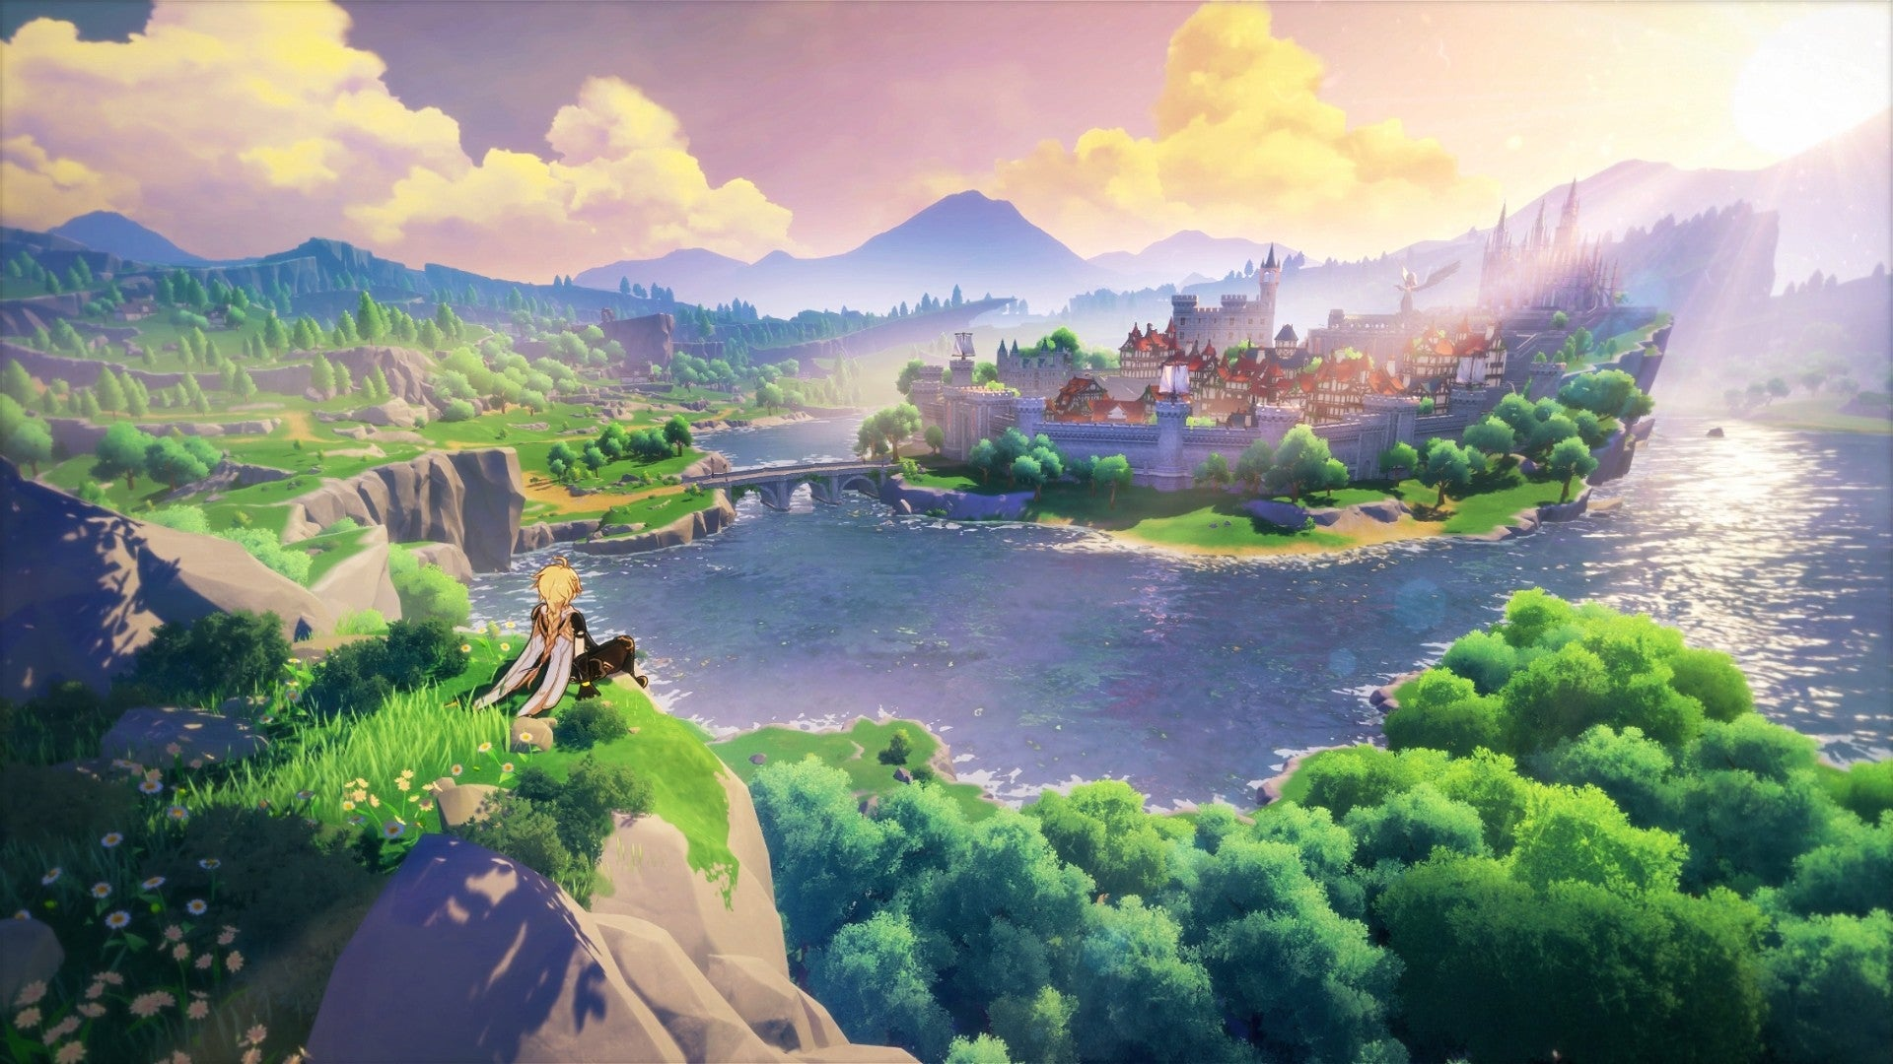

* **Release Date:** 2020
* **Developer:** miHoYo
* **Platforms:** Android, iOS, PC, PlayStation 4, PlayStation 5
* **Playable offline:** No
* **Price:**Free-to-play with optional microtransactions

Not many gacha games have managed to become household names in worldwide markets, but it's easy to see why [Genshin Impact](https://www.vg247.com/games/genshin-impact) has become such a notable exception once you've spent some time in its vast fantasy open world. Sometimes compared to a free-to-play Legend of Zelda: Breath of the Wild, fears that the game would be too derivative of its inspiration proved to be unfounded, and after three years, Genshin Impact's large and varied cast of characters in particular have become recognizable in their own right.

We've already alluded to a large part of Genshin's appeal coming from [one of the best open worlds in games](https://www.vg247.com/best-open-world-games), and there's so much to do that you'll certainly never get bored — although you might end up slightly overwhelmed. Happily, though, there is an interesting story tying the whole production together, meaning that Genshin has something for everyone, no matter whether you're a lore fan, a character collector, or enjoy ignoring the plot and just exploring.

